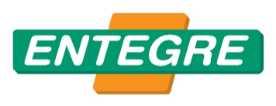
TECHNICAL DATA SHEET

MAHYA HARCI
Cement Based Polymer Added Ridge Adhesive Mortar

APPLICATION FIELD
It is used on gluing and fixing of ridges.

PROPERTIES
High adhesion strength.
Complement to the roof visually as it has a colour close to tile.
Easy to prepare and apply.

APPLICATION
SURFACE PREPARATION
The surface of application shall always be free of form oil, dust, paint and materials that reduce adherence. Application surface shall be dampened with water.

MORTAR PREPARATION AND APPLICATION
Ridge mortar is mixed with a trowel or electric mixer. 6-6.5 litre of water for 25 kg bag).

While preparing the mortar:

Water shall be put to the vessel first, then RIDGE MORTAR shall be added.

It shall be mixed thoroughly so that no aggregation shall be left.

Stop for 5 minutes, and stir again to achieve a homogeneous mixture.

Ridges shall be fixed to each other from their indents using RIDGE MORTAR while they are placed on the ceiling frame.

Sides of ridges shall be filled with RIDGE MORTAR so that no gap is left.

After 1 hour, it shall be finalized with a damp sponge

CONSUMPTION
600 grams average for 1 ridge

TECHNICAL DATA

Color | Tile red
Application Time, hour | ≤ 2
Incrustation Time, hour | Avg. 1

PACKAGING AND STORAGE
- In 25 kg polyethylene reinforced paper bags, it is shipped with pallets if requested.
- Storage Period is 1 year from the date of production if stored in its original package without opening the package under dry, frost free conditions and is stacked as maximum 8 bags, and 1 week after opening the bag.

RECOMMENDATIONS
- No other materials (lime, cement, gypsum, etc.) shall be added to the prepared plaster.
- It is recommended to apply at temperature between +5 °C, +35 °C.
- Must not be applied on surfaces exposed to sunlight for a long time and frozen.
- Mortar shall never be used again if its application time has expired.
- Do not go beyond the application field and the rules.
- Do not inhale it directly. Wash your eyes with plenty of water in case of contact with eyes, seek medical advice if required.
- For detailed information, please request the safety data sheet.
- Contact us for your technical questions and for your questions about all other application conditions.

CERTIFICATE OF CONFORMITY
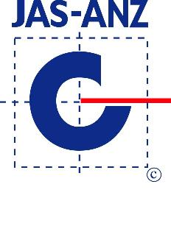
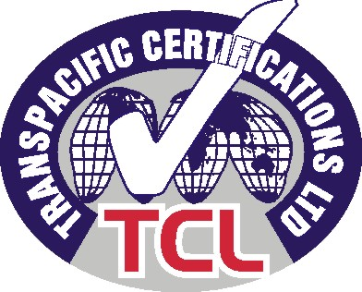

Above stated data obtained in lab conditions. Entegre will not be liable for any defect in product occurring by reason of events or conditions not within its control such as misuse, mishandling, improper storage or improper installation.
Entegre reserves the right to revise the information contained herein without prior notice.

ENTEGRE HARÇ SAN. Ve TİC. A.Ş
HÜSEYİNLİ VILLAGE, BEYKOZ STREET. No:222/4 34799 Çekmeköy/İSTANBUL T: 0216 434 50 96 F: 0216 434 50 31 www.entegreharc.com.tr

