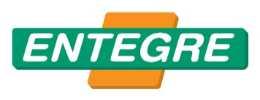

KAROFİX FLEX®
Cement-Based, Elastic Tile Adhesive Improved with Additional Characteristics

APPLICATION FIELD

Provides superior performance in fixing of coating materials such as ceramic, granite, marble, etc. on horizontal and vertical surfaces for interior and exterior areas.
It may be applied on dry and wet areas, cement-based plasters and concrete surfaces, floorings with floor heating system, and floors with high level of traffic passing over them.

PROPERTIES

Polymer added.
Water and frost resistant.
Provides high performance with its elasticity.
Comfortably used in indoor and outdoors, horizontally and vertically.

APPLICATION

SURFACE PREPARATION

The surface shall always be free of form oil, dust, paint and materials that reduce adherence.

Repair of the cracks and holes shall be made using appropriate Entegre Repair Mortars before application.

Application surface shall be dampened with water, if required.

PRIMEL 100® shall be applied before application on surfaces that are not resistant to moisture such as plasterboard, cardboard, gypsum plasters, etc. and the fixing operation is started when drying is complete (after approx. 24 hours).

MORTAR PREPARATION AND APPLICATION

First water is put into mixing bowl, then KAROFİX FLEX® is added. (6-6.5 litre of water for 25 kg bag) and mixed until the lumps go away. Wait 5 minutes, and then mix again to obtain a homogeneous mixture. Prepared mortar is applied on the surface up to 8 mm thickness, raked and ceramic is bonded. For a good adhesion, application shall be performed by applying force on the surface with a rubber hammer.

Double-sided bonding must be done for coatings larger than 1.600cm². Grouting application may be performed at least 24 hours later than Karofix Flex application.

CONSUMPTION
Applies to one-sided application.

Rake Size | Consumption, (kg/m2)
3 | 2-3
4 | 3-4
6 | 4-5
8 | 5-6

TECHNICAL DATA

Open Time: Tensile Adhesion Strength, N/mm² (min 20 minutes later), (EN 1346) | ≥ 0,5
Working Time, Hour | < 2
Adhesion Strength (Dry Environment), N/mm² (EN 1348) | ≥ 1
Adhesion Strength (Wet Environment), N/mm² (EN 1348) | ≥ 1
Adhesion Strength (Hot Environment), N/mm² (EN 1348) | ≥ 1
Adhesion Strength (Cold Environment), N/mm² (EN 1348) | ≥ 1
Slip, mm (EN 1308) | ≤ 0,5
Reaction to Fire | A1

PACKAGING AND STORAGE

- In 25 kg polyethylene reinforced paper bags,
- In dry and frost free environment, in its original package unopened, it must be consumed in 6 month from the date of production, provided that it is stacked as 8 rows. It is recommended to consume in 1 week after opening the bag.
- When not in use, the bag must be tightly closed.

RECOMMENDATIONS

- No other materials (lime, cement, gypsum, etc.) shall be added to the prepared mortar.
- Plaster shall not be used again by mixing with water or dry plaster if its application time has expired.
- May be used for coatings with water absorption of ≤0.5 and > 0.5 (ceramic, granite and porcelain ceramic, marble, etc.).
- The following coating areas are suitable for an ideal application:
Indoor floor ≤1600 cm²
Outdoor floor ≤1200 cm²
Indoor and outdoor walls: Coating area ≤1200 cm² (4 m height)
- KAROFİX FLEX® White is recommended for light color coating.
- It is recommended to apply at temperature between +5 °C, +35 °C.
- For an ideal application, the coating material must be adhered to the mortar in 25 minutes.
- For heights above 8 m, additional mechanical precautions are required.
- Must not be applied on frozen surfaces.
- Do not apply under direct sunlight.
- Do not use out of the application field and instructions.
- Do not smell directly. In case of contact with eyes, rinse immediately with plenty of water and seek medical advice if necessary.
- Please request the product safety data sheet for more information.
- Please contact us for your technical questions regarding all other application conditions.

CERTIFICATE OF CONFORMITY
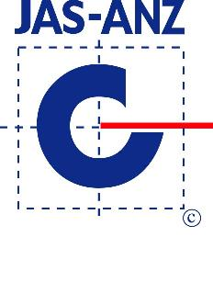

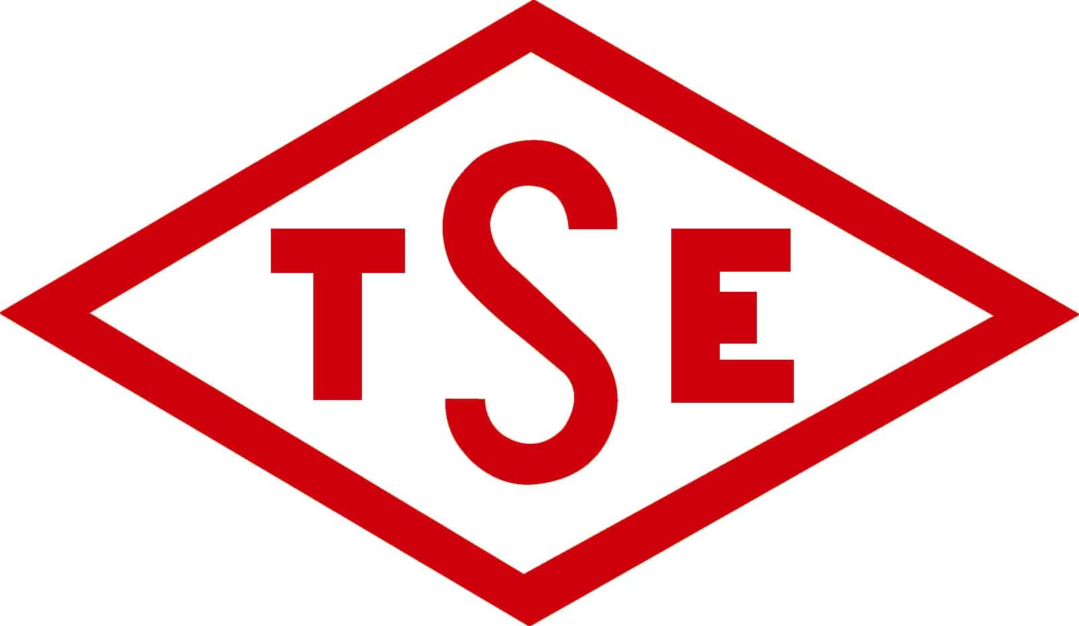
 TS EN 12004-1 / April 2017 / C2T
C2: Cementitious adhesive improved with additional properties
T: Adhesive with reduced slip
Public Work Items No: 04.013/1

Above stated data obtained in lab conditions. Entegre will not be liable for any defect in product occurring by reason of events or conditions not within its control such as misuse, mishandling, improper storage or improper installation.
Entegre reserves the right to revise the information contained herein without prior notice.

ENTEGRE HARÇ SAN. Ve TİC. A.Ş
HÜSEYİNLİ VILLAGE, BEYKOZ STREET. No:222/4 34799 Çekmeköy/İSTANBUL T: 0216 434 50 96 F: 0216 434 50 31 www.entegreharc.com.tr

