FUGAFIX®
Cement-Based Grout
23 Different Colour Options Grout for joints from1 to 6 mm width

FIELD OF APPLICATION
Used for filling of joints of ceramic and tile coating materials on horizontal and vertical floors in interior and exterior areas in dry and medium wet environments.
CHARACTERISTICS
Applied easily.
It has a smooth appearance.
Used conveniently on interior and exterior surfaces both vertically and horizontally.
APPLICATION
SURFACE PREPARATION
Scrape any dust, chipping, construction-cement waste that may be present inside the joint hole and clean with a brush before application. Joint hole shall be dampened with water before application, if required.
PREPARATION AND APPLICATION OF THE MORTAR
Water shall be put to the mixing container first, then FUGAFIX® shall be added (6.5-7 l water/20 kg bag) and it shall be mixed until the lumps are removed.
Wait for 5 minutes, and mix again to achieve a homogeneous mixture.
The mortar prepared shall be applied with a rubber ended scraper with a suitable thickness.
Approximately 30 minutes after the application, surface shall be cleaned with a damp sponge.
This period may be shorter for coating materials with heated surface or with high water absorption rate and for applications that are performed under improper conditions.
Fluctuation may occur on the joint surface when the wiping operation is performed before its due time or with an excessively dampened sponge. Sponge shall be cleaned frequently.
After ensuring that FUGAFIX® is cured so that it shall not be drained from the joint gap, clean any residues on the surface with a dry cloth.
Application surface shall be damped at least 1 days after the application.
When the surface cleaning operation is not performed adequately, the joint filler residues on the coating may be cleaned with a suitable cement stain remover (PRIMEL 300®) after 10 days.
CONSUMPTION
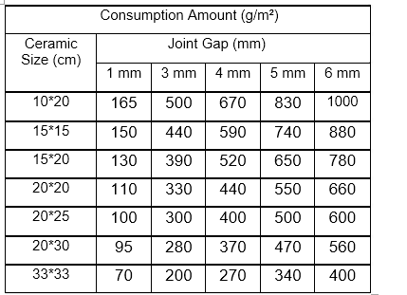
*Coating material with a low water absorption rate at a thickness of 10 mm is taken as a reference. (For other sizes, please refer to the Joint Filler Consumption Calculation at the end of the catalogue.)
TECHNICAL DATA
Application Time, hours | < 2
Water Absorption, 30 minutes later, g (EN 12808-5) | ≤ 5
Water Absorption, 240 minutes later, g (EN 12808-5) | ≤ 10
Shrinkage, mm/m (EN 12808-4) | ≤ 3
Bending Strength After Dry Storage, N/mm² (EN 12808-3) | ≥ 2.5
Bending Strength After Freezing-Thawing Cycle, N/mm² (EN 12808-3) | ≥ 2.5
Compressive Strength After Dry Storage, N/mm² (EN 12808-3) | ≥ 15
Compressive Strength After Freezing-Thawing Cycle, N/mm² (EN 12808-3) | ≥ 15
Abrasion Resistance, mm³ (EN 12808-2) | ≤ 2000

PACKAGING AND STORAGE
Available in 5 kg polyethylene bags and 10 and 20 kg polyethylene-reinforced paper bags, delivered in pallets or as sling-bags upon request.
Storage period; It is recommended to be consumed in 6 months from the date of production if stored in its original package without opening the package under dry, frost free conditions and is stacked as maximum 8 bags, and in 1 week after opening the package.
Packages shall be tightly closed when it is not used.
RECOMMENDATIONS
• No other materials (lime, cement, gypsum, etc.) shall be added to the prepared mortar.
• Plaster shall not be used again by mixing with water or dry plaster if its application time has expired.
• Wait at least 24 hours for joint application after fixing operation.
• We recommend that the application shall be performed between +5°C and +35°C.
• It shall not be applied on frozen surfaces.
• Do not apply under direct sunlight.
• PRIMEL 300® shall be used for cleaning of the contaminated joints.
• To prevent damage to the coloured joint fillings, do not use strong chemical cleaning agents such as lime remover, hydrochloric acid, etc.
• Do not go beyond the application field and the rules.
• Do not inhale it directly. Wash your eyes with plenty of water in case of contact with eyes, seek medical attention if required.
• For detailed information, please request the safety data sheet.
• Contact us for your technical questions and for your questions about all other application conditions.
CERTIFICATE OF CONFORMITY
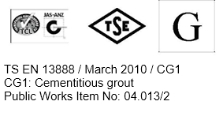

Above stated data obtained in lab conditions. Entegre will not be liable for any defect in product occurring by reason of events or conditions not within its control such as misuse, mishandling, improper storage or improper installation.
Entegre reserves the right to revise the information contained herein without prior notice.
ENTEGRE HARÇ SAN. ve TİC. A.Ş.
HÜSEYİNLİ VILLAGE, BEYKOZ STREET. No:222/4 34799 Çekmeköy/İSTANBUL T: 0216 434 50 96 F: 0216 434 50 31 www.entegreharc.com.tr

